Kewalinvest 4th Round of testing--

- Contacts-

After Converting contact to customer ( test2), it should reflect in customer count as well as customer list ....once the contact converted to customer convert button should disappear for particular contact. Resolved 12-12-2025
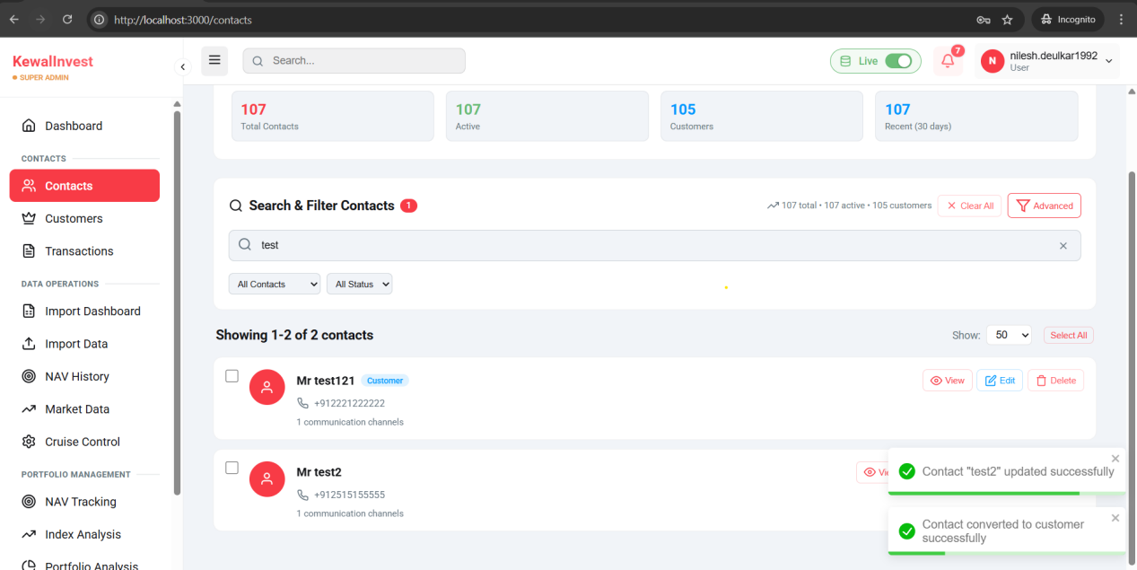
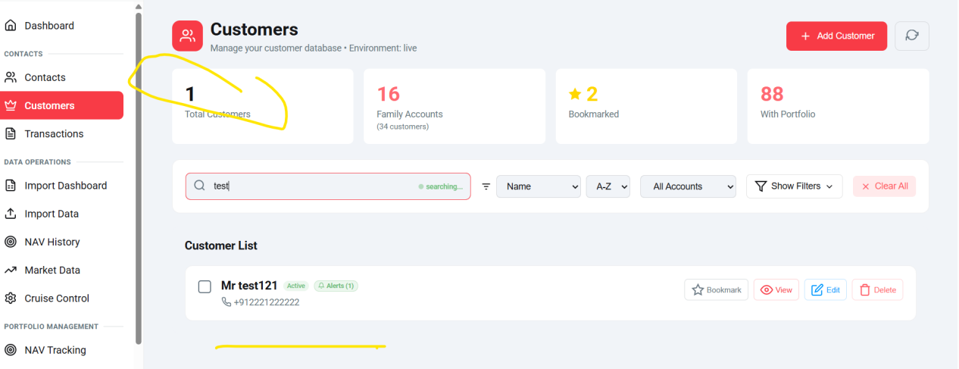

Same communication method should accept only one method as primary here its allowing to mark all as primary...
Communication channel un-tick is not working for Set as primary mobile channel.. Resolved 12-12-2025
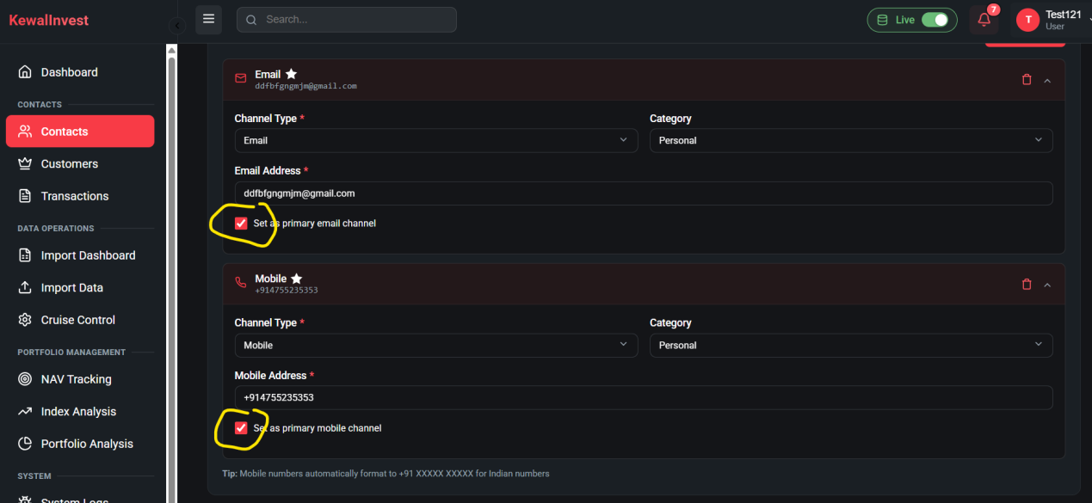

- Import Dashboard----Bookmark Data
There are difference in Count of Total records and successful , 7 records are missing.. Resolved 12-12-2025

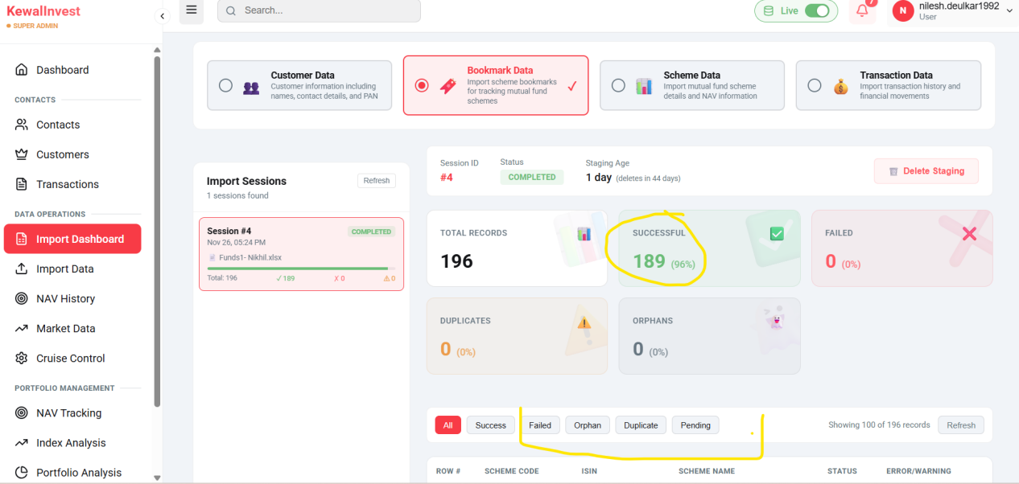

Import Dashboard Pagination Issue
Under the Scheme bookmark list of data is showing only 100 records and next page is not showing further records.. Resolved 12-12-2025

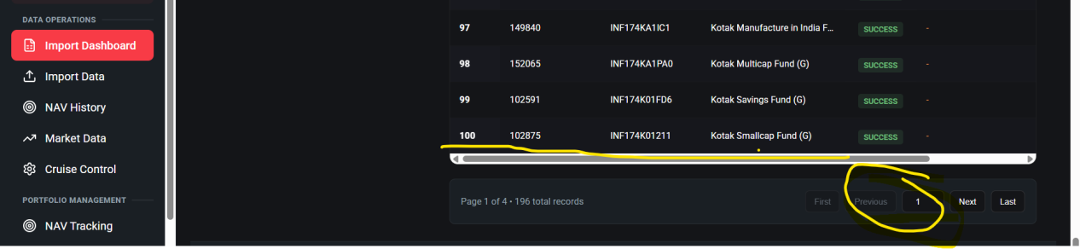
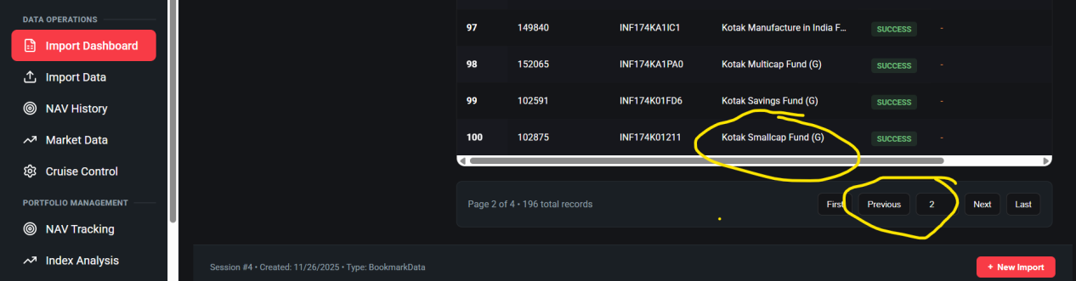

Orphans section is not showing orphan count but data is showing in list..--Resolved 12-12-2025
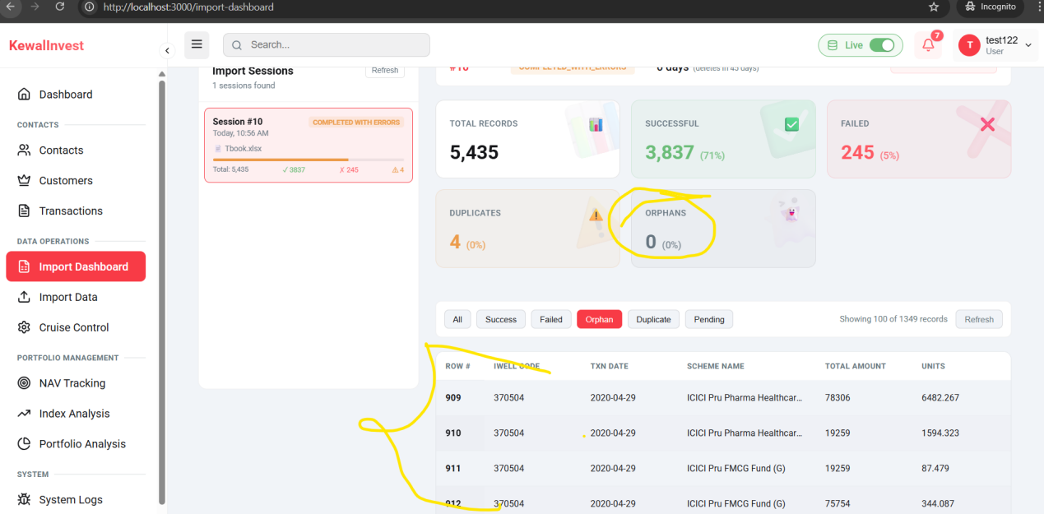

Networth projection calculated till 1 Year for 24M its showing same as 1Year-- Resolved 12-12-2025
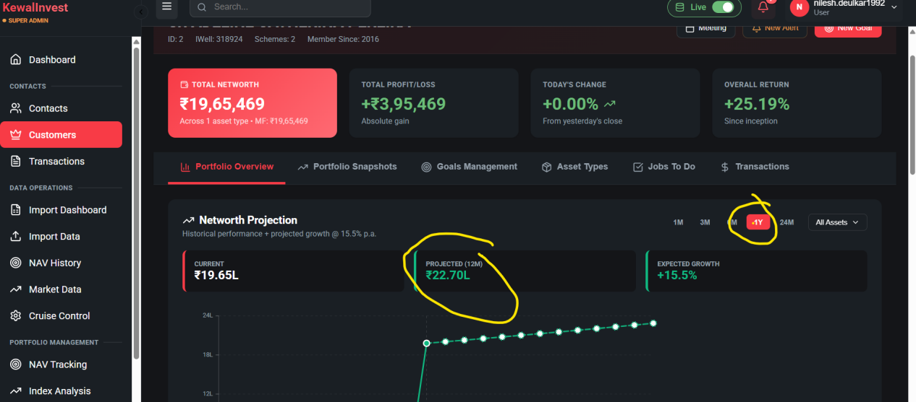

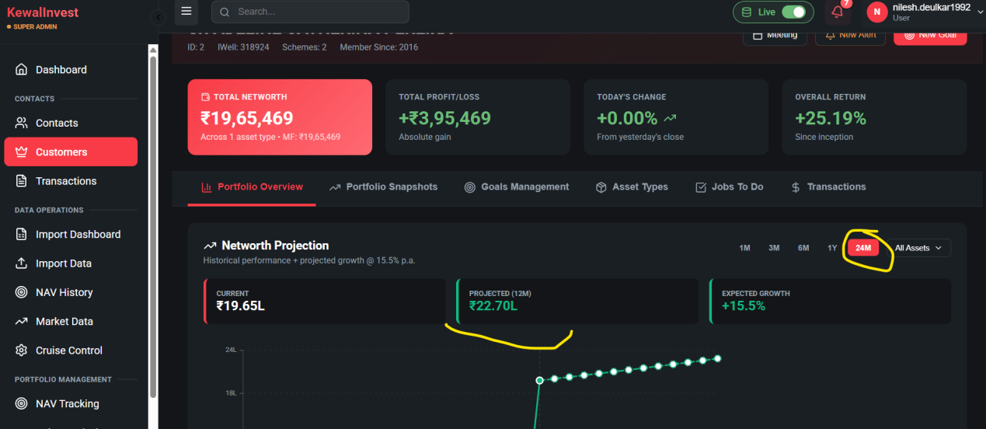

Customer -Edit is not updating new changes to customer details.--Not Resolved
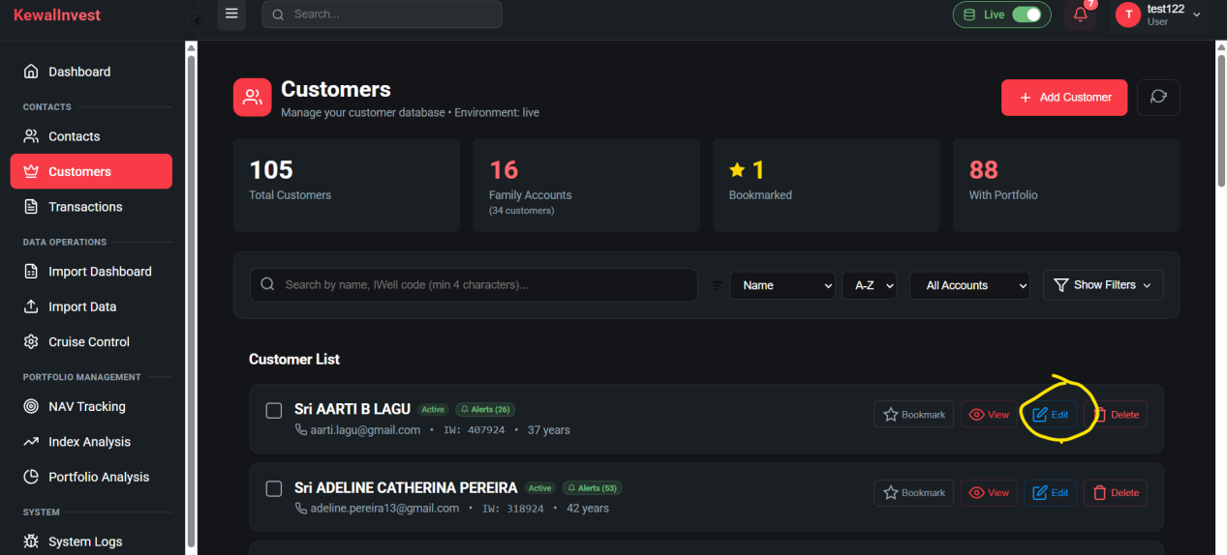
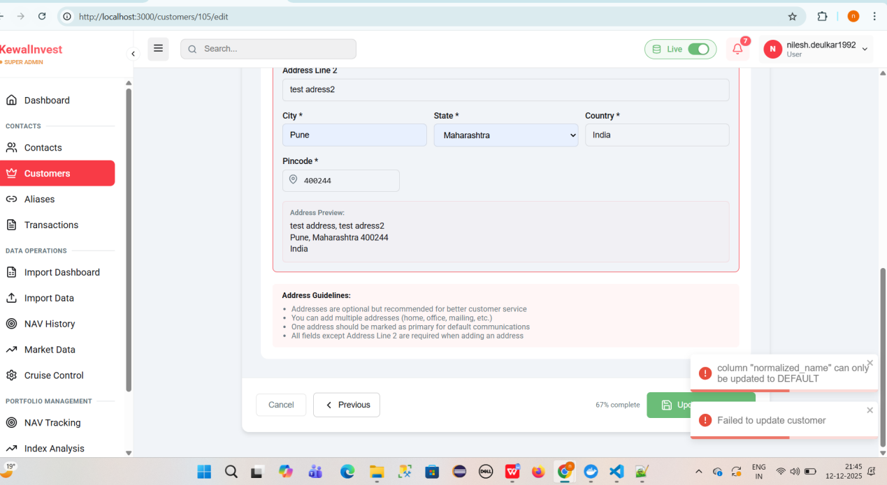

Customer-New Alert
Unable to create alert expecting table configuration in db-Resolved 12-12-2025
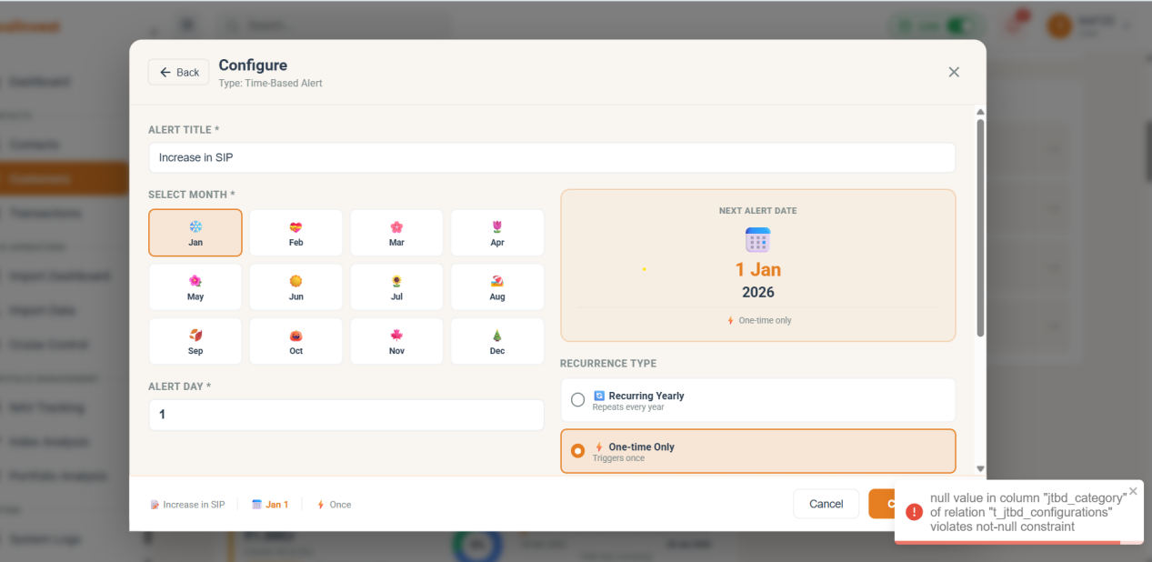

Customers----Goal Management-
Facing error while updating monthly contribution in time based goal setting-Resolved 12-12-2025
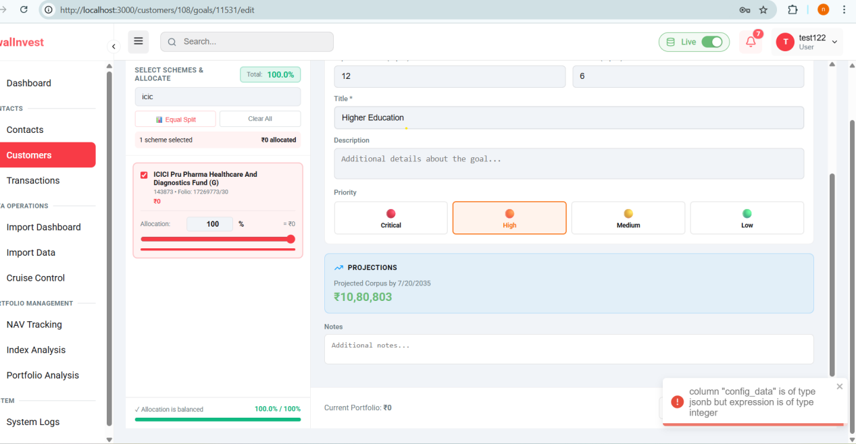

Customers----Goal Management-
Facing error while creating price based goal.--Not Resolved
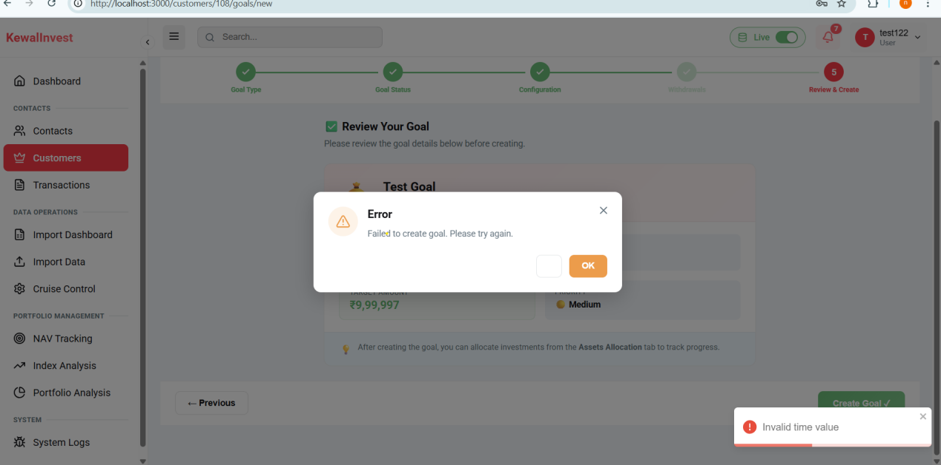

While adding goal to watchlist, its not updated showing database table does not exist error-Not Resolved
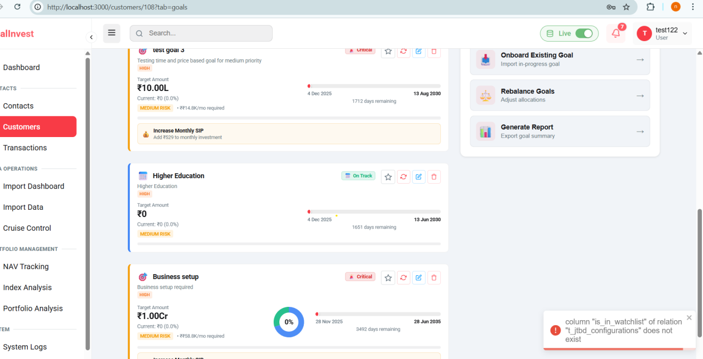

Transaction- Search by scheme name or code is not filtered the records..Resolved 12-12-2025
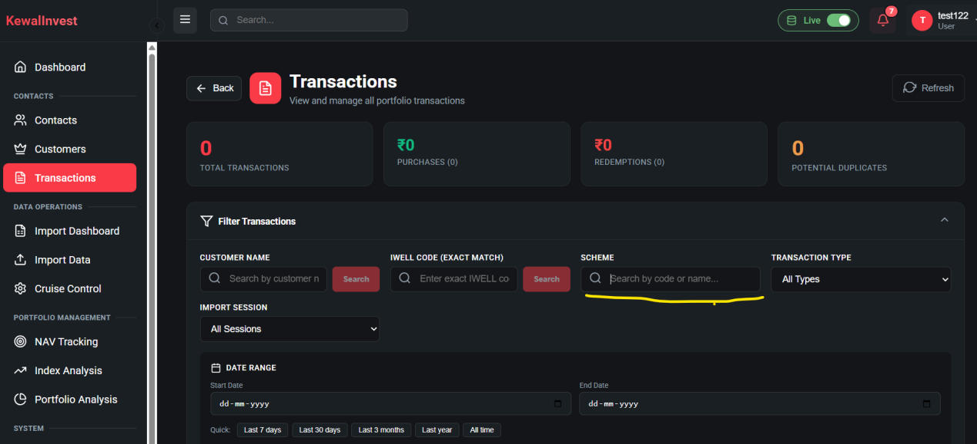

- Cruise Control
NAV downloads-- NAV Downloaded still its showing pending----Modified need to discuss
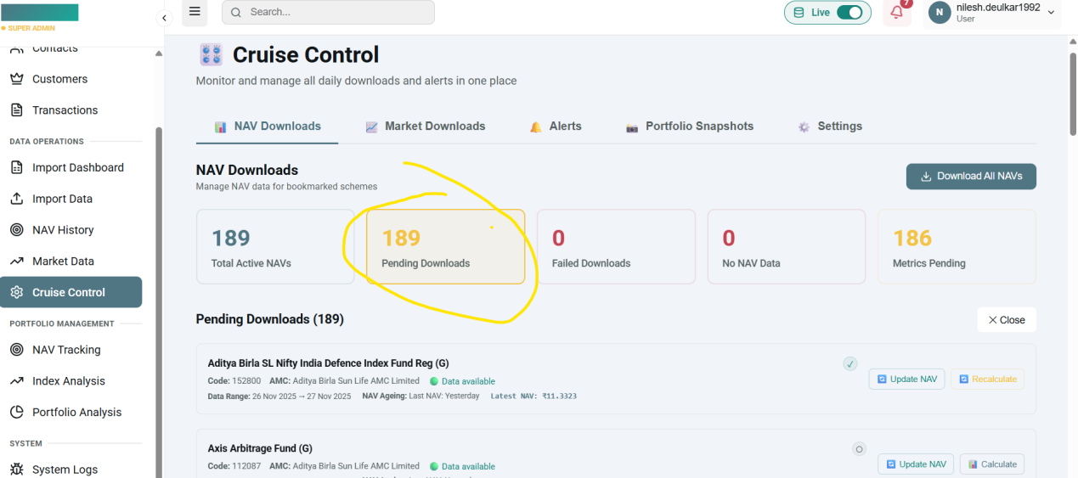

Cruise Control---NAV Downloads
Failed Downloads tab not showing failed count ..Removed
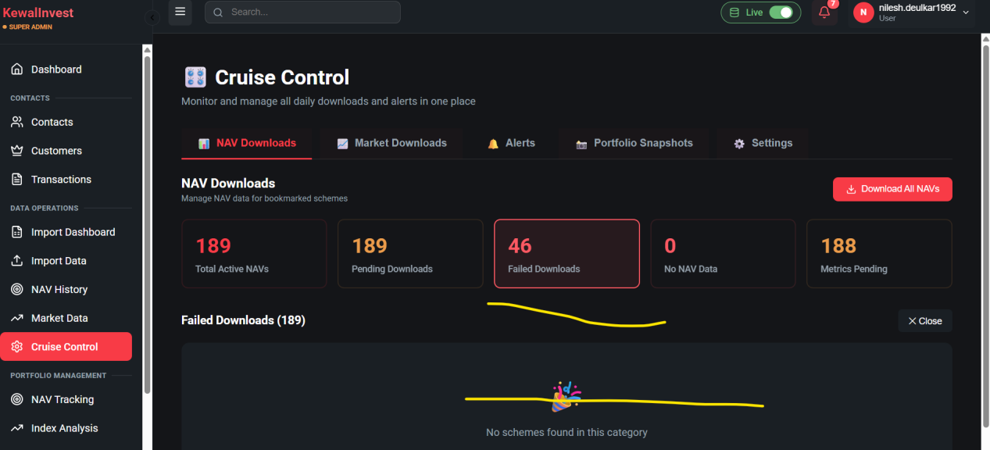

Customers-Transaction
In Customer Transaction history sort by filter is not showing the filtered records for all the scenarions newest, oldest, A-Z, Z-A--Resolved 12-12-2025
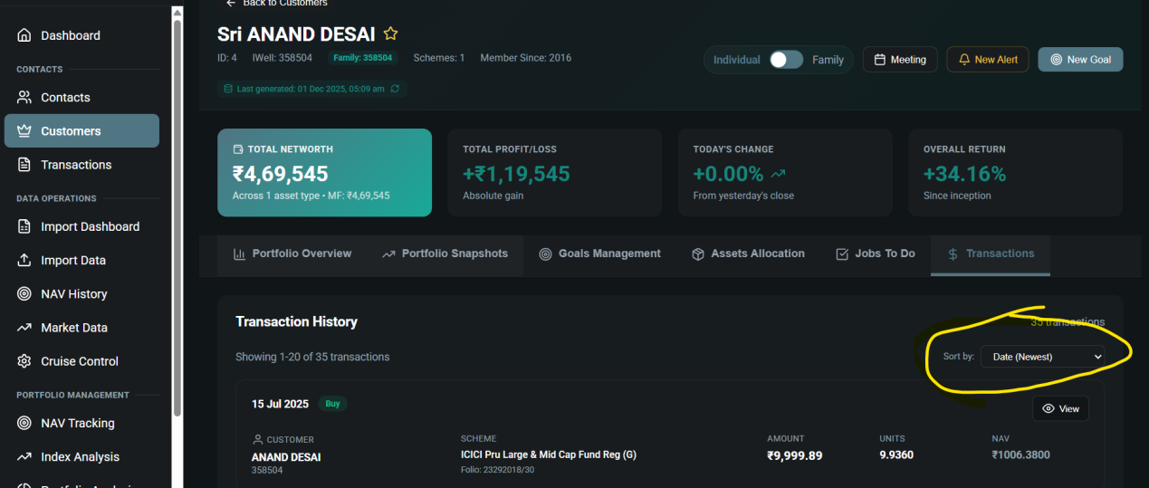

Customer--Porfolio Overview
After Clicking on Upcoming alerts it is redirecting to active goals-Resolved 12-12-2025

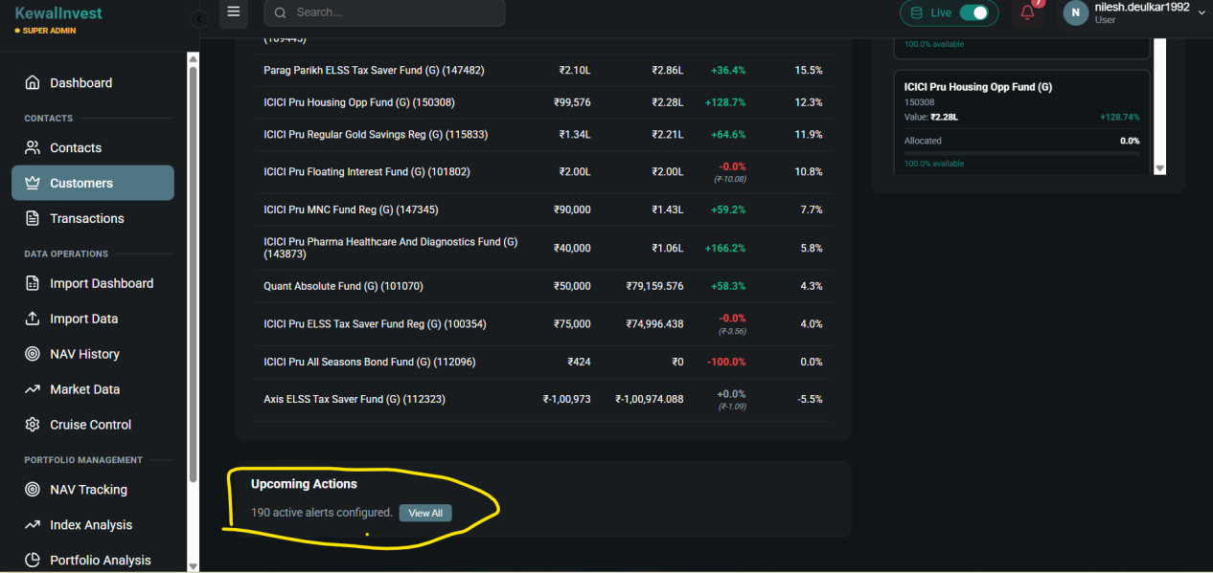

5th Round of Testing
Issues New-
In Customer-Jobs To Do -Items grouping are not showing appropriate results.
Upcoming, Due today, overdue, completed count is not changing for SIP plan and alerts tab.
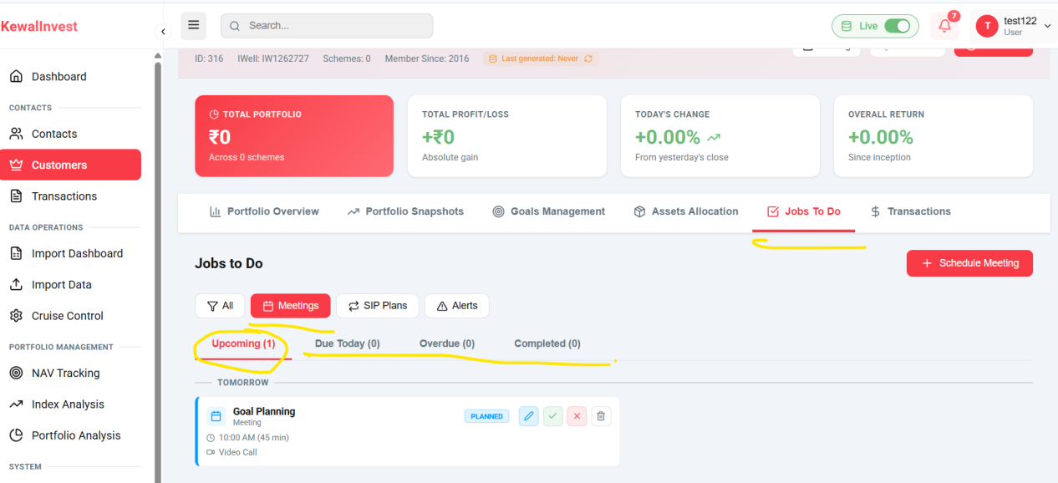
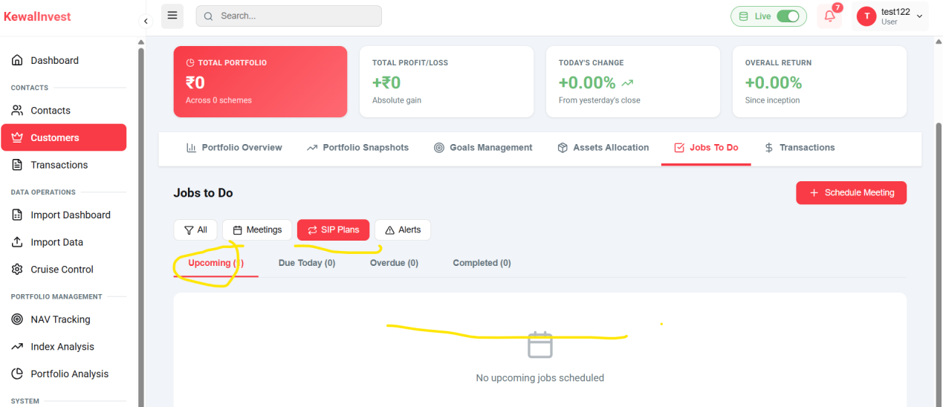
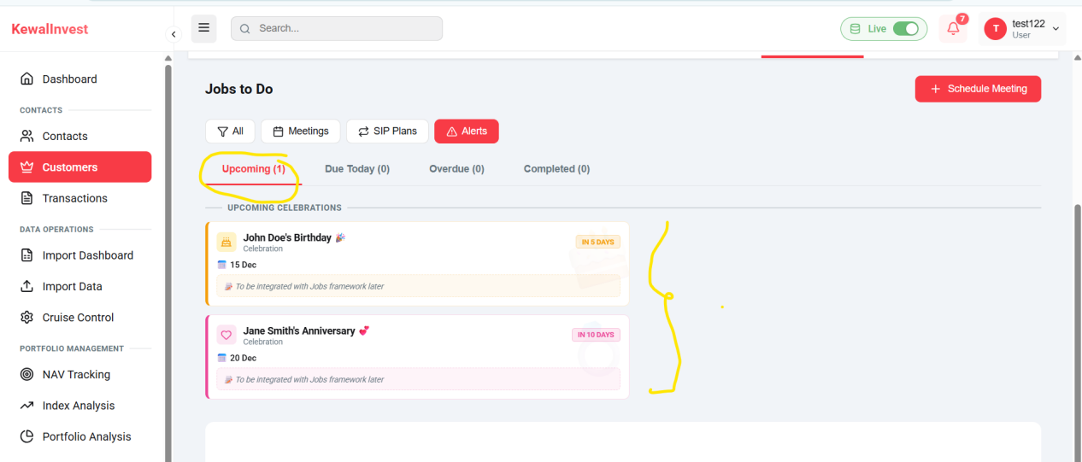

Search box in Customer Module returns no results for any search query-
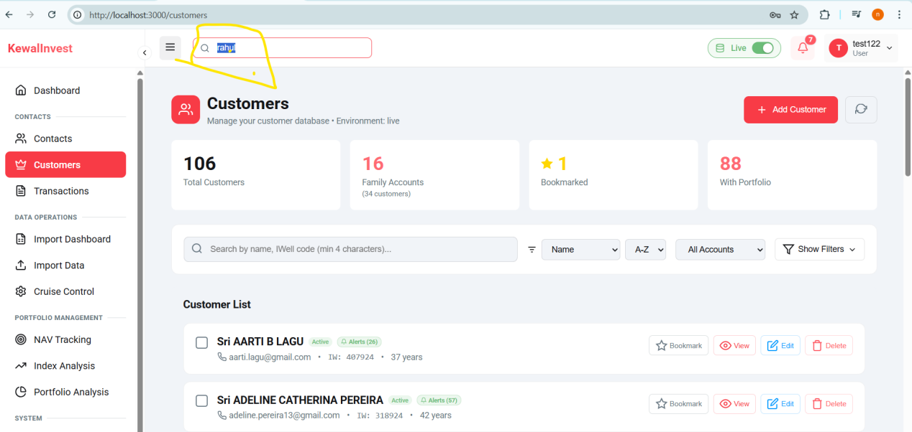

Alias--
Alias is not working because t_customer_alias does not exist
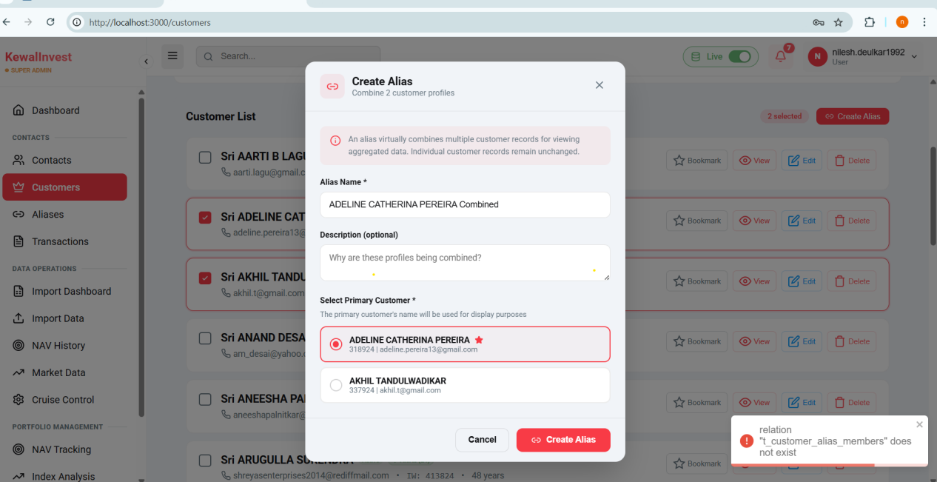

Transaction type filter is not showing records for redemption.
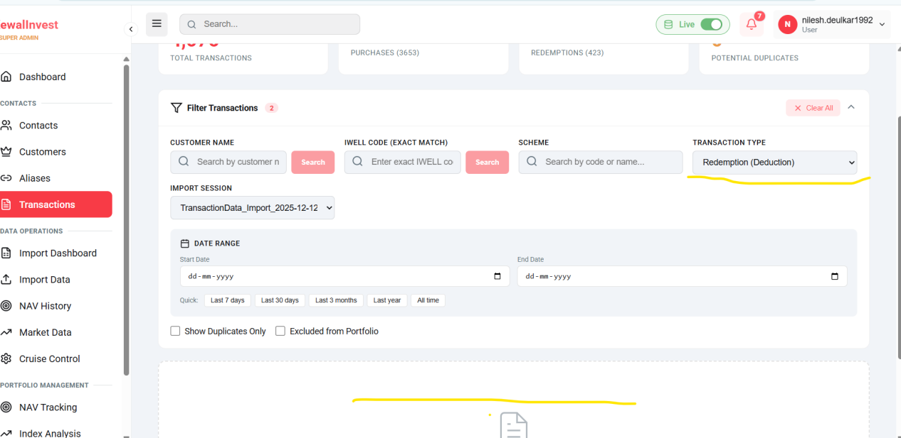

Cruise Control ---Individual Nav is not getting downloaded-
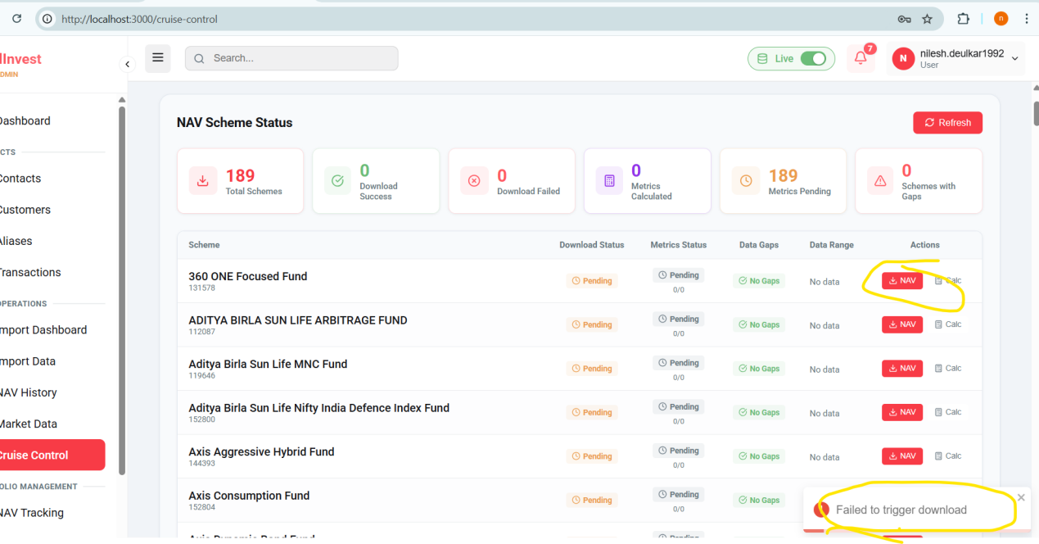

Alerts have configured for IWell: 318924 but it is not showing in Alert Tab--
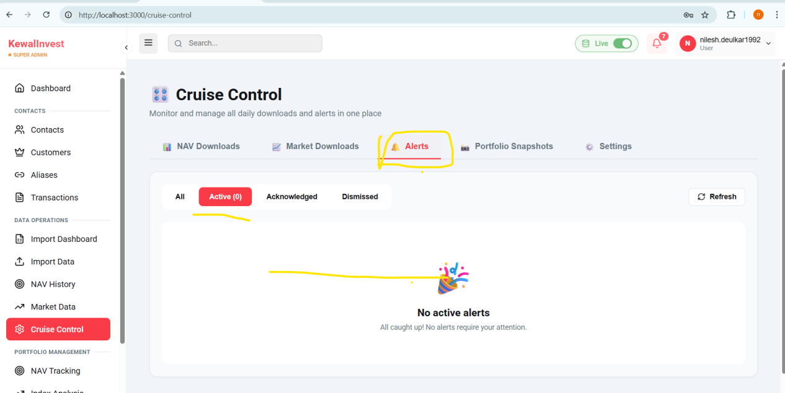

The 'Daily Download Disabled' filter is not working as expected and fails to filter the records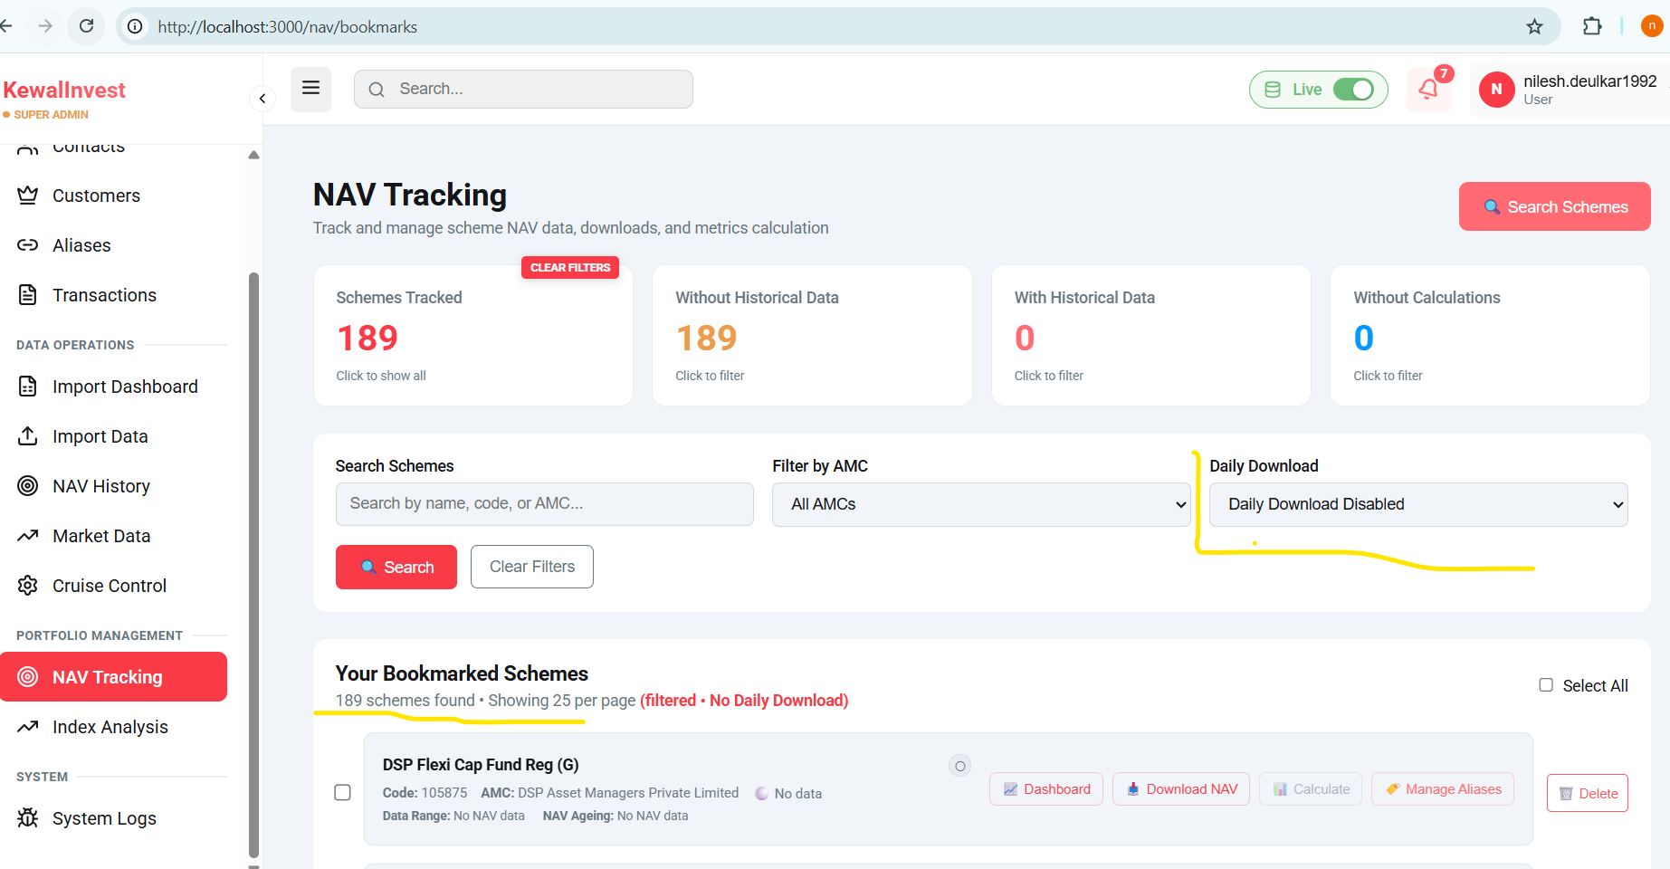

The Transaction Type' filter is not working as expected and fails to filter the records for Redemption and count is not matching for Purchase(addition)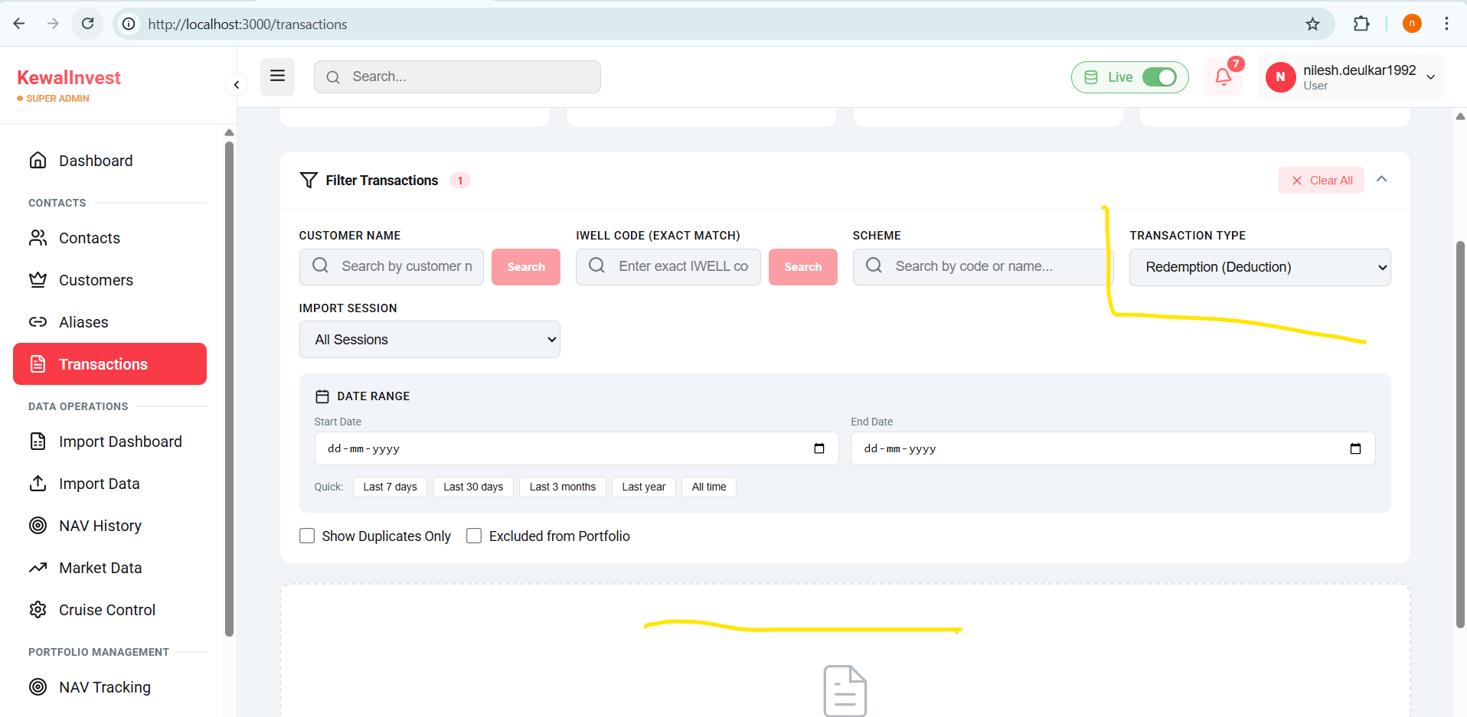

After Deleting Alias its not allowing us to create fresh alias for same customer.
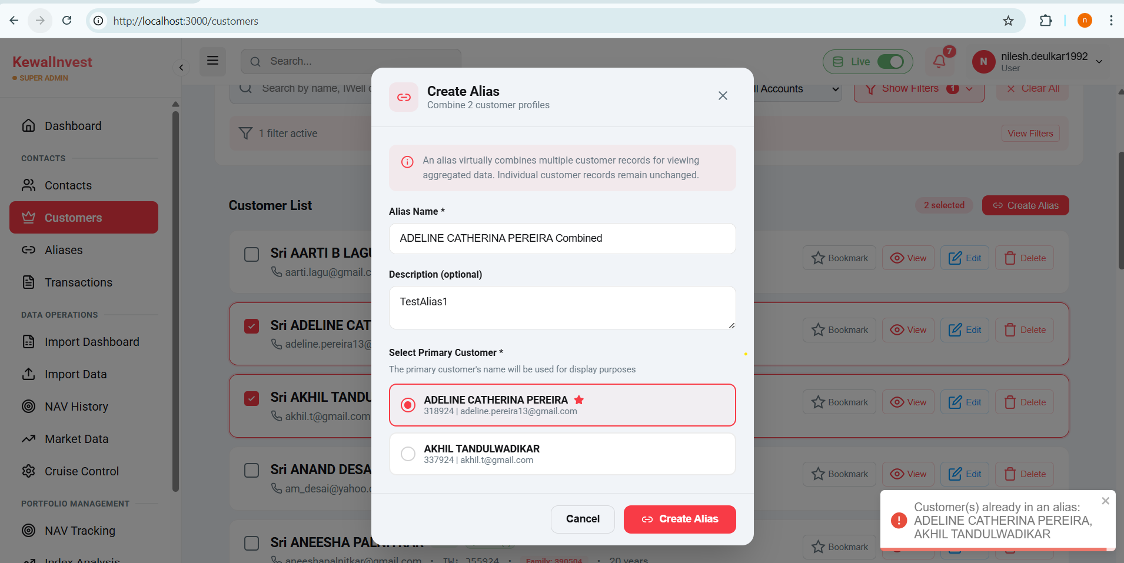
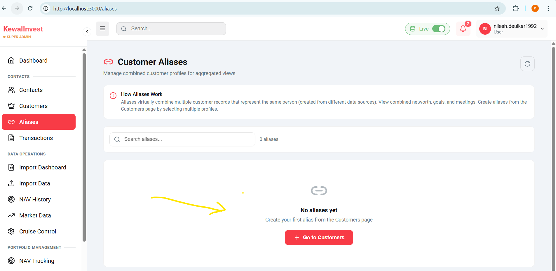
Profile trigger alert for Anniversary is not getting created “Create Alert” tab is showing inactive.
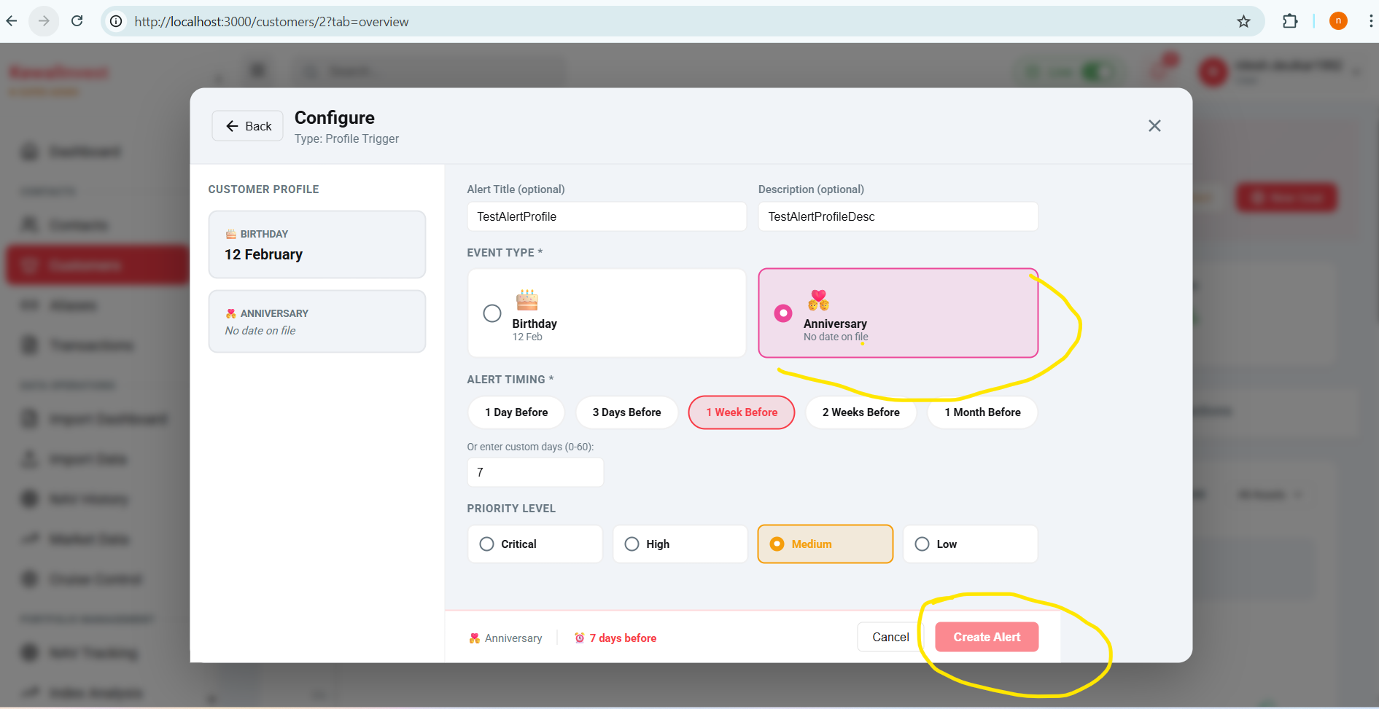

Auto download NAV is taking default time 9pm, I have changed it to 3pm but its not getting updated showing same 9pm default time.
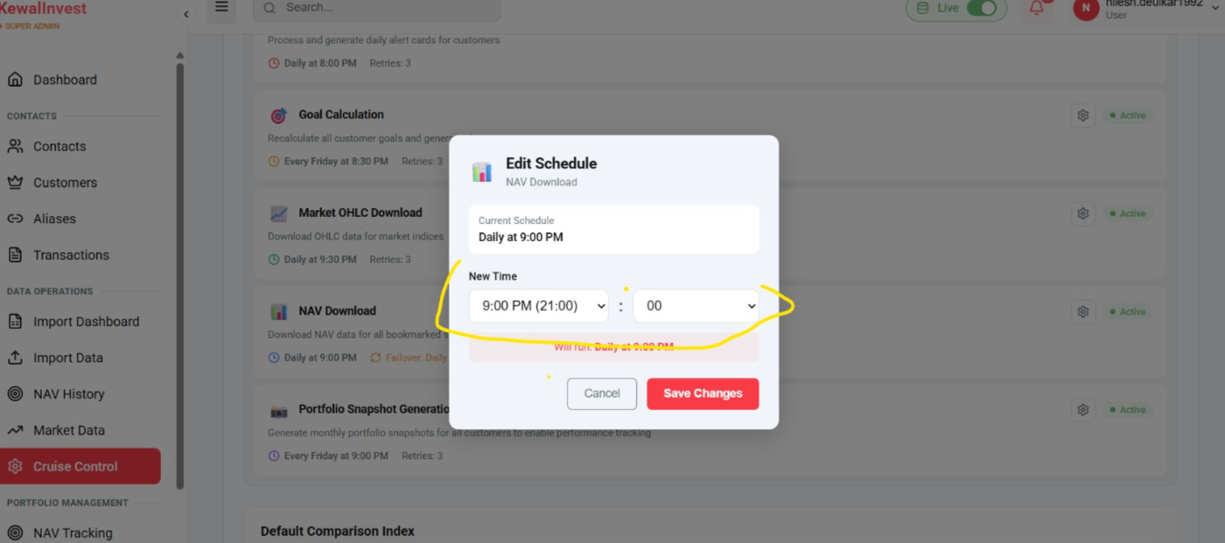

NAV History filter (All/Success/Failed) is not filtering records correctly 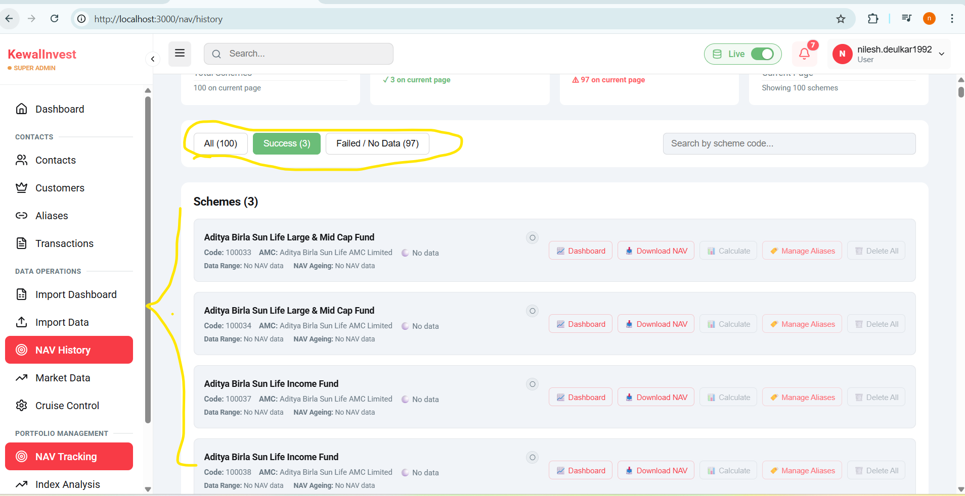

Market Data-
All filters are not filtered the records.
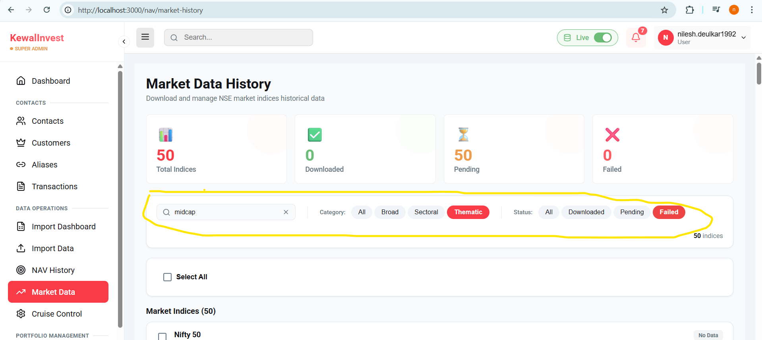

Dashboard cards displaying "No data" or empty states despite having active data in the system
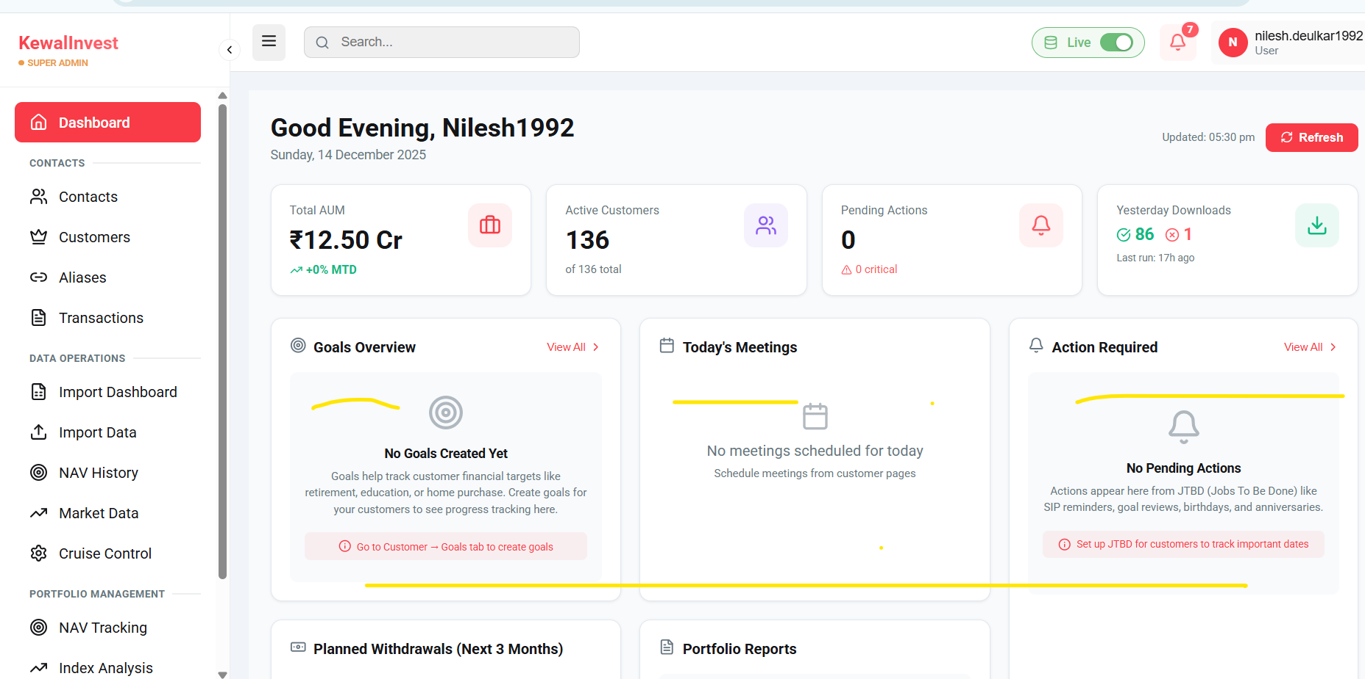

Notification alerts not navigating to the corresponding customer/location when clicked
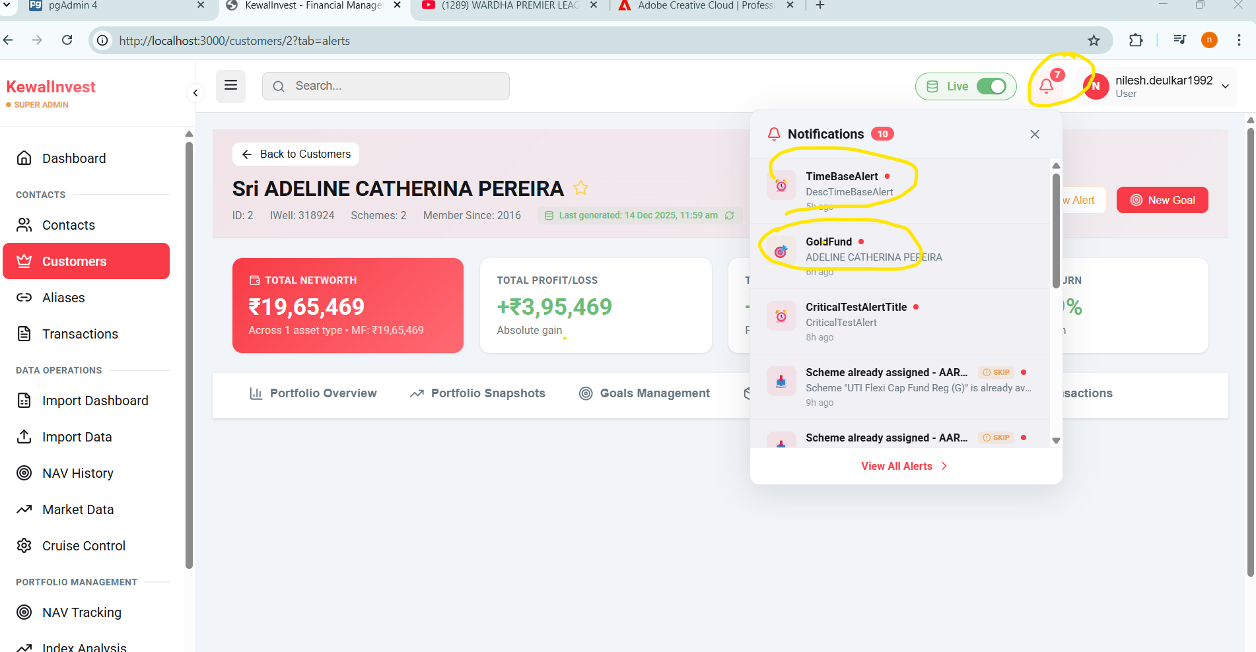

Customer Profile Snapshot Calculation Need to discuss ..
There are difference in market value and Mom% calculation
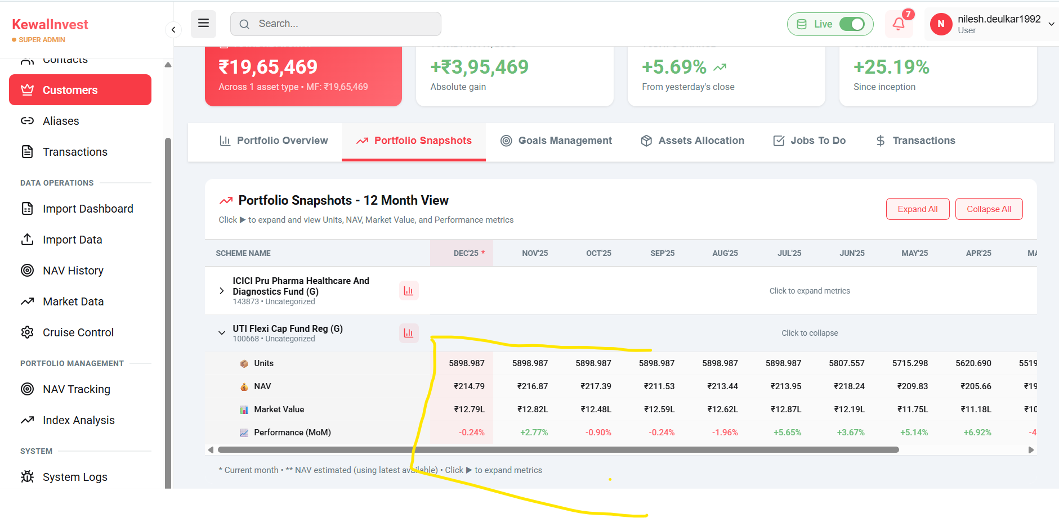

------------------------------------------------------------------------------------------------------------------------------------------------------------------------------------------------------------------------------------------------------------------------------

Following are the use cases need to confirm with client aboot requirement----
Total Networth calculation is not getting calculated as per profile snapshot, its taking last purchased NAV value.
UTI Flexi Cap Fund Reg (G) (100668) 216.8718 * 5898.987 total units ----Actual
Calculated Nav 328.1022
ICICI Pru Pharma Healthcare And Diagnostics Fund (G) (143873)
40.5300 Nav * 1642.853 ---Actual total units -------------Actual
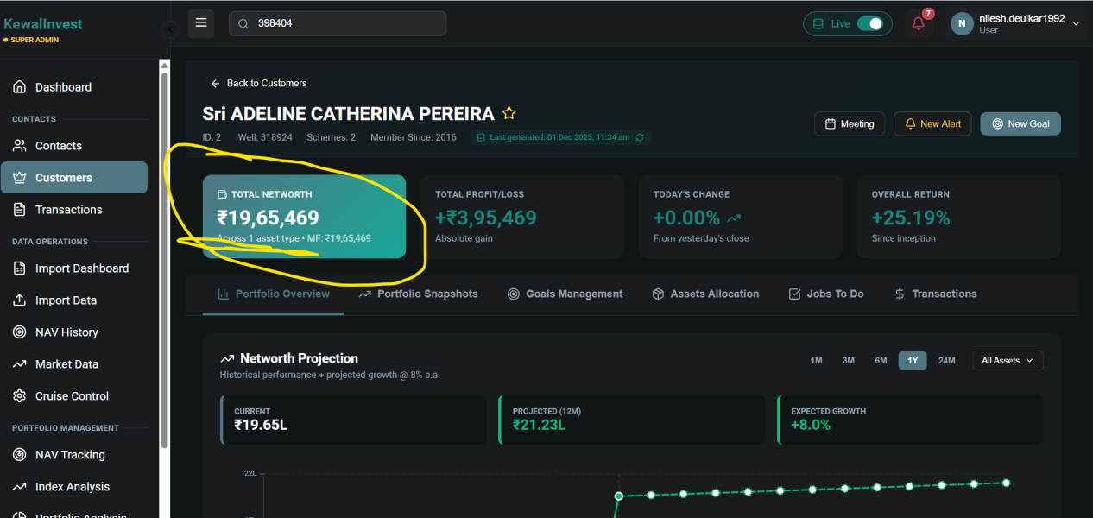
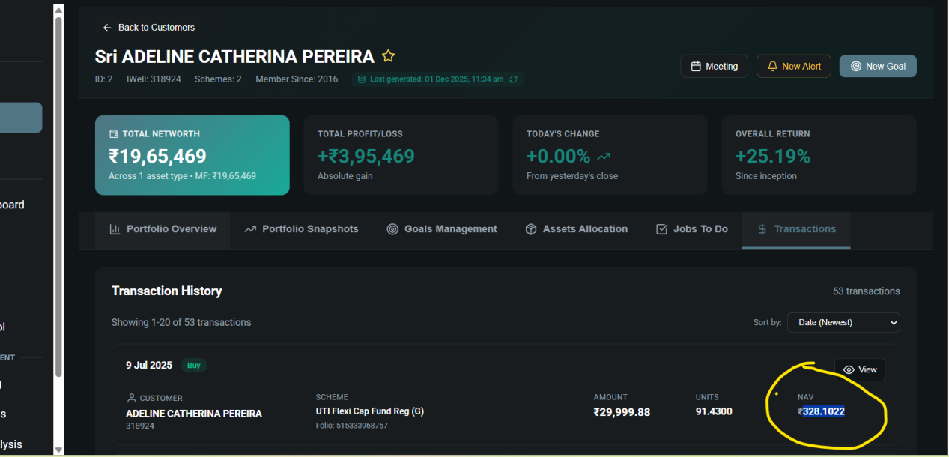

In Customers view transaction
If we click on transaction then it will redirect us to transaction module tab and then again we need to come back to customers module and check for new transaction..
